Sales Prep- <https://drive.google.com/drive/folders/16cYJE0X7DH16C9oGLbPpVuxpx2E-WJa2>

FIN-TECH DOCUMENT

Concept Note.

Financial technology (better known as Fintech) is used to describe new tech that seeks to improve and automate the delivery and use of financial services. ​​​At its core, fintech is utilized to help companies, business owners, and consumers better manage their financial operations, processes, and lives by utilizing specialized software and algorithms that are used on computers and, increasingly, smartphones. Fintech, the word, is a combination of "financial technology."

When fintech emerged in the 21st century, the term was initially applied to the technology employed at the back-end systems of established financial institutions. ​Since then, however, there has been a shift to more consumer-oriented services and therefore a more consumer-oriented definition. Fintech now includes different sectors and industries such as education, retail banking, fundraising and nonprofit, and investment management, to name a few.

Fintech also includes the development and use of cryptocurrencies, such as [Bitcoin](https://www.investopedia.com/terms/b/bitcoin.asp). While that segment of fintech may see the most headlines, the big money still lies in the traditional global banking industry and its multi-trillion-dollar [market capitalization](https://www.investopedia.com/terms/m/marketcapitalization.asp).

**Why is Fin-Tech important?**

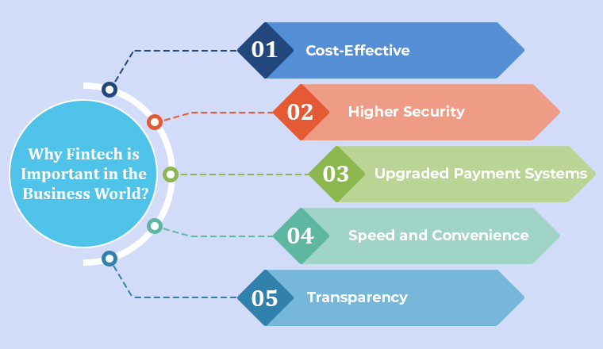

Businesses are no longer limited to implementing old-school ways or conventional ones, all thanks to the fintech revolution. Today one is surrounded by a plethora of alternatives and options ranging from crowdsourcing to net banking to mobile payments. More or less, unlike earlier, now anyone can set up his or her own business in no time with the help of fintech.

For those who don’t know what Crowdsourcing is? By using such financial services anyone can create instant plans on how and most importantly where to get finance from. Here you don’t need to meet others in person. Instead of spending so much time convincing your investors today, businesses can pitch seamlessly.

Transferring money across borders was a curse earlier! Time to get acquainted with TransferWise – the innovation which turned the table entirely. Not just large enterprises but even startups are found moving cash conveniently at cost-effective rates.

1. **Financial Services are Pretty Cost-Effective**

Of course, you are well-versed with the fact that global payment services have proven as a pure blessing for a plethora of communities. But what you may not know is that global remittance is a costly venture and not every business has the potential to afford it.

Moreover, each time you transfer the money the processing fees automatically fluctuate. Using Fintech services, businesses could save from charging these unnecessary fees. There are a plethora of financial tools available. So, one no longer has to worry about any cancellation fees or any other hidden charges, they can send or receive money across the world instantly in different currencies through mobile devices.

Lastly, can anything think of integrating physical and digital payments? Well, now this is a reality where multiple bank accounts are using a single interface. And you know what is the best part? This fintech software is beneficial for consumers as well.

1. **Compliance + Security = Fintech**According to several sources, traditional financial services companies have lagged way behind in regard to security. Unfortunately but that’s true! Now since Fintech’s fundamentals include the effective use of tech, compliance and security won’t be such a problem.

When it comes to fintech companies, they don’t particularly have one regulator. This is one of the most important reasons why so many fintech startups have started appearing. And without strict regulation, these fintech firms can make changes to their business and they don’t have to follow any type of strict guidelines. This makes it very simple for fintech startups to adapt to their client’s requirements and work faster in this risky industry.

As you know that fintech regulations have a flexible nature and this could make it riskier for the industry. But because of its benefits like robust, less expensive, highly user-friendly experience, and innovative nature, it is considered to be a better option than traditional banks.

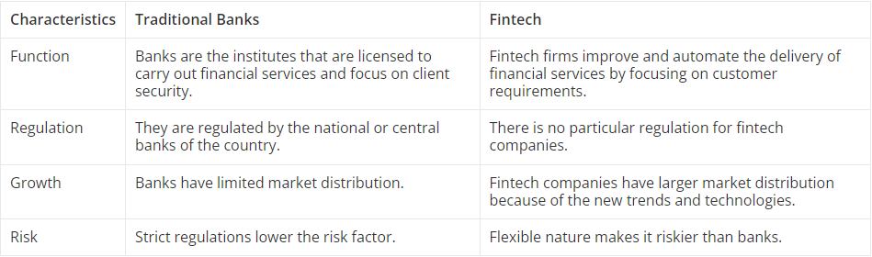

1. **Upgraded Payment Systems**

After security comes the upgraded payment systems. We are living in a dog-eat-dog world, if you want to raise a cut above using fintech software turns out to be a must-do thing. As a result, nothing can stop your business from being effective. Which is possible only by using upgraded payment systems. Also, this leads to enhanced business-client relations, and increased ROI.

1. **Speed and Convenience is Best for Companies as well as Customers**

Since we mentioned this earlier, offering instant results and taking care of your customers has become a priority for every industry and fintech is no exception. Now it has become possible to offer payments or lend money right away digitally in no time. For example, let us assume that you want short-term loans or some money just for a day. We know you will come across a wide range of potential businesses who would like to offer. These are the ones making the most of the tech and maintaining the economy.

1. **Transparency**

With the rise of Fintech in the traditional banking and financial services sector, the term transparency is no longer just said. In fact, it is being meant and implemented by the vendors. Several new benchmarks have been set by vendors all across the globe. Other than just sending or receiving money everyone is kept in a tight loop featuring full transparency. A win-win situation for the banking industry as well as their valued customers.

Of course, you do get all the other perks such as 24/7 dedicated customer support, real-time updates and tight security measures and whatnot!

**Fintech In Practice in India**

The Fintech Tech or financial technology industry in India has come of age, especially after the boost it received post demonetization by Prime Minister Narendra Modi led central government. Now, we can see a sign of its popularity in the data that mobile payments were more than ATM cash withdrawals last year.

India is the third-largest startup ecosystem globally and is currently valued at $31 billion and is expected to grow to $84 billion by 2025. India is one of the fastest-growing fintech markets in the world, and of the over 2,000 fintech in the country today, over 67 per cent have been set up in the last five years.

Rising transactions resulted in more startups joining the fray and incremental investments chasing them. India was the top destination for fintech investments in the Asia-Pacific (APAC) region, with $1.93 billion raised across 66 deals in the third quarter of 2021, according to the S&P Global Report.

India, along with South-East Asia, accounted for 70 per cent of all investment in the APAC region. "With the possibility of digital banks and the entry of fintech into the banking ecosystem, we can expect technological innovations expanding the reach and furthering the process of making financial inclusion a reality," says CEO and Co-founder of Vivifi India Finance, Anil Pinapala.

The fintech landscape has also changed over the years. Apart from payment apps that dominate the sector, business-to-business platforms are also picking up in the fintech space. For the sector to grow, investments will be needed both from private equity players and the primary market.

With venture capital raising more money, Indian fintech is well placed to attract more capital, especially since China's fintech is no longer a popular destination, thanks to their government's crackdown on the new technology players. "Fintech is a large space and there might be more interest for blockchain, crypto and lending in 2022," says founder of Credit Fair, Aditya Damani, Founder.

The Fintech industry has been one of the favourites for investors this year. According to a report by PwC India, investments worth $4.6 billion were recorded in the fintech space in India in the first three quarters, as compared to $1.6 billion in 2020.

“Fintech has been at the forefront of driving innovation in various applications including loans, payments, stock trading, and credit scoring," Says Suhail Sameer, CEO, BharatPe.

Sameer added that the coming year will witness the rise of Digital Banks, driven by cutting-edge technology. The future belongs to tech-driven banks that offer convenience via digital products.

FinTech has the potential and already has disrupted the financial system in tier 2 and tier 3 market space. Due to the lack of traditional financing infrastructure with retail banks that are much behind in digitisation, FinTechs have been the answer for the people, as far as borrowing, investing and financial planning are concerned.

A lower cost of services in FinTechs gives them a major advantage in becoming an integral part of the consumer need.

Also, there is a healthy adoption of UPI in several cities making people more conversant with digital payments. It augurs very well for the future when these customers can be provided other financial services too.

The future in this segment is bright. Digital payments are no longer limited to Tier -1 cities. 2020 and 2021 have witnessed a huge growth in the adoption of digital payments across tier-2,3 and 4 towns and cities.

"The migration from cash and in-store commerce to paying online or on-the-go through next-gen payment methods such as contactless payments, digital wallets, mobile payments and QR payments is a clear trend not just in the metros, but also in tier I, II and III cities," states Rishi Chhabra, General Manager – India and Sri Lanka at Fiserv

The biggest opportunity for us is the huge unmet credit gap amongst millions of SMEs in India. "The last couple of years have been tough for lenders; their balance sheets have been hit hard and lending volumes depressed. Stronger consumer confidence will drive demand for personal loans and purchases via BNPL," mention Rohit Sen, Co-founder, and CEO, NIRA

As for the primary market, there are some important fintech IPOs lined up in 2022 which will give a boost to the sector. Given the growth expectation, if market conditions are right, these IPOs should sail through.

"For the sector to grow, investments will be needed both from private equity players and the primary market. With venture capital raising more money, Indian fintech is well placed to attract more capital, especially since China's fintech is no longer a popular destination, thanks to their government's crackdown on the new technology players. As for the primary market, there are some important fintech IPOs lined up in 2022 which will give a boost to the sector. Given the growth expectation, if market conditions are right, these IPOs should sail through." Vikas Singhania, CEO, TradeSmart.

Needless to say it is pretty evident that the fintech space is not only an emerging market rather it has already emerged and is here to stay!

**Segment wise Industry Deep Dive**

1. **LENDING**

India as a consumer market is fairly complex in terms of geography, cultural preferences and consumer behaviour. For any given product or service, there are multiple consumer segments, each with its own unique set of buying preferences. But a common unifying factor is the ubiquity of mobile connectivity and the rapid adoption of the internet as a data source influencing the buying decision.

The primary mode of accessing potential borrowers in need of credit, of credit underwriting and entering into loan agreements is offline through brick-and-mortar outlets supported by call centres. Banks and NBFCs rely heavily on hardcopy documents, on traditional data sources like income statements and credit scores, on face-to-face meetings and on wet signatures. This makes technology just another support system for the brick-and-mortar world of doing business. The full leveraging of technology and true digitisation in the lending business started with Fintech companies in India. The two segments that have been the focus of Fintech lenders are urban individual consumers and the MSME segment.

**The fintech lenders disrupting the unregulated market**

Traditionally the major block of unsecured lending in India is controlled by community finance – comprising family, community members and unregulated private lenders. This segment was ripe for disruption through technology and remains the segment of focus for Fintech lending start-ups in India. Even MSMEs in India are heavily cash starved in spite of being willing to submit to onerous processes and wait times. This credit gap is also the target of many Fintech lenders in India. Receivables financing, working capital financing and equipment finance are the solutions that Fintech lenders provide to this borrower segment.

Happy Loans is an example of how Fintech lenders address the needs of the MSME segment. Happy Loans in its current business model provides loans against receivables to retail merchants. Happy Loans focuses on retail merchants who have been acquired by merchant aggregators. Aggregators have a record of electronic transactions of their merchants done through open loop payment systems, mobile wallets, remittance mechanisms etc. Aggregators are also the channel through which merchants receive their dues through daily settlement. A tie-up with such aggregators gives Happy Loans access to electronic transaction data used for credit underwriting. The aggregator also enables the repayment of loans disbursed through daily split settlement of electronic transactions at a merchant outlet. The entire value chain of prospect acquisition, credit underwriting, loan disbursement and repayment is completely digital thus bypassing the need for brick and mortar stores, physical documents and lengthy wait times. Happy Loan’s business model is supported by an AI engine which performs credit underwriting based on transaction data thus making redundant data points like income statements, credit history and credit score.

**Business Models**

1. **Point of Sale transaction based lending-** This is the model that Happy Loans works on today. Credit is extended using data of electronic transactions at POS and against future receivables at POS.
2. **Bank Fintech partnership model-** In specific segments (travel, food and hospitality for e.g.) banks have tied up with Fintech companies that source and underwrite potential borrowers for banks. Indifi is an example of the same.
3. **Invoice discounting exchanges-** Some Fintech companies like KredX operate exchanges where unpaid invoices can be discounted by SMEs to a network of financiers (Banks, NBFCs), wealth managers and retail investors.
4. **Marketplaces**- Marketplaces like Paisa Bazaar connect borrowers with financial institutions. They provide the value add of digitizing the entire supply chain to provide borrowers with a seamless digital experience.
5. **Captive models**- Companies that exist in entirely different businesses are entering the lending space in order to lend to their captive customer base either directly by setting up NBFCs (like Flipkart) or by partnering with financial institutions (like Ola)
6. **P2P model**- Companies like Faircent have set up P2P lending platforms in order to connect borrowers to affluent individuals with excessive liquidity. The Individual nature of lenders as opposed to institutions separates this model from marketplaces.

For winning business models and successful companies, the payoff is huge. The underlying product – credit, is essentially a commodity. Companies that will succeed are companies who innovate in customer acquisition and servicing. Some likely future developments within this industry:

Traditional lenders will form exclusive or near exclusive tie-ups with Fintech companies

The use of alternative data for credit underwriting will increase

Trusted third party data platforms will emerge

The future for this industry is one of growth and profitability while at the same time closing the crippling credit gap in India thus boosting economic growth and creating social impact. Fintech lending will gain market share initially in segments underserved, and progressively in adequately served segments transforming the traditional lending business model completely.

**PAYMENTS**

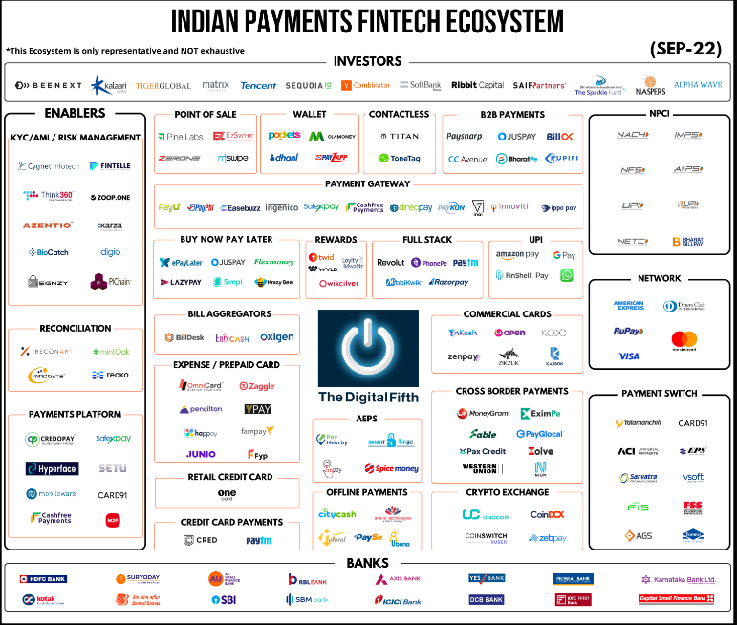

Adoption of Digital payments in India is increasing so are the products on offer to multiple customer segments. Popularity of NPCI products like Rupay, UPI and BBPS are extending the reach of these products in India. Digital transactions in India have grown close to 90% in last 3 years.

This growth has been accelerated by the COVID-19 outbreak and the social distancing norms that it has brought with it. With people switching to contactless payment methods, the number of digital transactions in the country has skyrocketed. And this trend is likely here to stay.

Apart from the pandemic aspect, the Indian government has also been a big contributor to this digital push. In the Union Budget of 2021-22, the Indian Government has announced a sum of 1,500 Cr to be allotted to boost the digital payments sector in the country.

**The Digital Payments Ecosystem**

A few of the criteria that have helped us choose the players are:

● Size, Market share, and popularity of the company

● The prominence of players in the segment

● Innovation in Business Model

● Type of Clients served



The bottom layer consists of banks, which are the backbone of the payment ecosystem. These entities are highly regulated by the RBI and are guided by stringent rules that dictate the payment systems they can provide to their customers, the fees they can charge, etc.

They are present on both the payer’s side and the payees, and also play the roles of issuer and acquirer banks. They play a central role in the RBI/NPCI Payments framework and Networks and also facilitate collaboration with FinTechs through Open APIs for payments

|  |  |
| --- | --- |
|  | **Enablers**  a. KYC/ AML/ FRAUD MANAGEMENT  These companies provide solutions to businesses that enable them to perform KYC and AML checks on their customers. They also offer digital Onboarding Services for customers and vendors. These tools also use AI/ML algorithms to track the anomaly or change in the data pattern and issue a warning to the businesses about the potential risk. |
|  | Enablers  b. RECONCILIATION  Reconciliation has been one of the major pain points across the industry. These companies help reduce this pain by automating the payments reconciliation process. In addition, these companies are trying to address significant gaps in the reconciliation process like a high volume of unstructured data, high manpower utilization, lack of transparency and traceability of transactions, and the high costs and time consumption in traditional reconciliation processes. |
|  | Enablers  c. PAYMENT PLATFORM  These companies provide APIs for the various use cases in the Payments Ecosystem. In addition, they offer Plug and Play API tools so that companies can go-to-the market in a shorter time duration. The APIs for different use cases are- Wallet and Cards, Cross Border Payments, UPI Payments, Reconciliation, and Collecting bill payments. We expect to see further growth in this segment in the coming years. |
|  | NETWORKS  These companies provide railroads for payments and enable cross-border transactions. These companies support the innovation in the Cards segment by coming up with Tap to Pay Cards and Tokenization process. Their next focus is on BNPL, IoT and blockchain-enabled payment solutions. |
|  | NPCI  National Payments Corporation of India (NPCI), an umbrella organization for operating retail payments and settlement systems in India, is an initiative of the Reserve Bank of India (RBI) and Indian Banks’ Association (IBA) under the provisions of the Payment and Settlement Systems Act, 2007, for creating a robust Payment & Settlement Infrastructure in India. They have been credited with revolutionizing the country’s payment ecosystem through market-leading innovations like UPI, BBPS,  AEPS etc. |
|  | PAYMENT SWITCH  These are the companies providing Payment Switches to the different Banks in India. These switches would enable integrations of the bank’s core platforms with Networks for ATM,POS, UPI, AEPS, APB etc. For example, ATM SWITCH is software connected to the ATM Machines of banks and enables the flow of information between the Core Banking Platform and ATM Machine. In addition, the ATM Switch of these companies is connected to the National Financial Switch (NFS) and is connected to the network of different Banks. |
|  | CROSSBORDER PAYMENTS  Cross-border payments are those payments where the payer and the payee are located in 2 different countries. This transaction may or may not involve converting one currency to another. The remittances received by Indian Citizens was around $76 Billion in 2020. According to RBI’s data, India gets the highest amount of inbound cross-border remittances globally. The companies are providing solutions for global payments and remittances. |
|  | FULL-STACK PLAYERS  those players who provide a complete suite of payments to customers. They focus on cross-selling financial services and products by driving customer experience. |
|  | BILL AGGREGATORS  They are players that integrate with customers or with billers to facilitate the payment of utility bills through a single platform. They are RBI authorized entities that enable billers (e.g., electricity board of a state) to connect with customers. Bill Aggregators receive payments from customers, pool them, and transfer them to the corresponding billers. Bill desk has the highest market share in this category. We expect to see  further growth in this segment as more players are expected to turn into a one-stop platform for all customer needs. |
|  | CREDIT CARD PAYMENTS  The companies operating in this segment rewards individuals for their timely credit card bill payments. They allow credit card users to manage multiple cards along with an analysis of their credit score. Only customers with a credit score above a certain  number are allowed entry on these platforms. This enables the companies to create a cohort of customers with high credit scores who can then be used to cross-sell other products. They also provide exclusive offers and access to premium experiences on the platform. Currently, players like Cred, Paytm are the only prominent players in this category. In 2021, record $ 5.5 billion transactions were made through this platform. |
|  | PREPAID CARDS  Prepaid Cards are preloaded payment cards that are not linked to a bank account specific to the customer. Prepaid cards being used for various use cases- Tracking of employee expenses, blue-collar job salary payments, customer loyalty schemes and  reward programs. Prepaid Cards have less stringent regulations as compared to credit and debit cards. We are expecting to see further growth in this segment. |
|  | COMMERCIAL CARDS  These companies provide credit cards to Startup, SME, and MSME segments. A commercial card is a credit card issued by employers for their employees to use to make purchases on behalf of their company. It helps businesses manage their expenses by collecting all charges made by employees into a single place and providing better credit access through the card. This fintech offers banks access to a customer base of SMEs and MSMEs that were previously too risky to engage with. This partnership may be facilitated through an FLDG model. The Fintechs in this segment may also provide value-added services like working capital loans around the capital and cash flow management. |
|  | RETAIL CREDIT CARDS  A credit card is a financial instrument issued by banks with a pre-set credit limit, helping you make cashless transactions. But traditional players provide these cards to only selected customers with pre-defined criteria. Players like Uni and One Card provides Credit Cards with a mobile app-driven customer journey for improving financial inclusion and re-imagining the experience of using credit cards  in India. |
|  | POS SOLUTIONS  These companies provide solutions like POS- POS Terminals, mPOS, and SoftPOS. A POS system designed to help retail stores sell in-store and online seamlessly, with built-in tools for advanced inventory management and sales management, sales reporting and analytics insights for business. Soft-POS is the new solution under the POS umbrella. It is mobile-centric and NFC-technology-based. This solution’s adoption rate has increased tremendously as it provides a cost-effective card acceptance solution for all micro-merchants and SMEs in India. |
|  | CONTACTLESS PAYMENTS  Contactless payment allows consumers to pay for goods and services using their debit or credit cards with RFID technology— also known as chip cards—or other payment devices without the need to swipe, enter a personal identification number (PIN), and/or sign for a transaction. The players in this segment use technology like Near Field Communication (NFC), Radio Frequency Identification (RFID), and Sound Waves to enable payments. NFC based payments have seen massive traction. |
|  | **B2B SOLUTIONS**  These companies provide payment gateways and payment solutions for B2B transactions. By using the solutions of these companies, businesses can track working capital, payables, and receivables through reports and dashboards. |
|  | PAYMENT GATEWAYS  Payment Gateway is a software application used to authenticate payments on a merchant’s website, primarily for Card-not-present (CNP) transactions. It plays a vital role in the online transaction process and authorizes transactions between merchants and customers. Payment Gateway Solutions are for both B2B and B2C. It is a critical component in creating seamless experiences for customer journeys |
|  | CRYPTO EXCHANGE  A crypto exchange is a platform on which you can buy and sell cryptocurrency. You can use exchanges to trade one crypto for another — converting Bitcoin to Litecoin, for example — or to buy crypto using regular currency, as the U.S. Dollar. Exchanges reflect the current market prices of the cryptocurrencies they offer. Platforms like CoinSwitch and CoinDCX are democratizing cryptocurrency investment and improving financial inclusion – that wealth, investment, and financial knowledge are for everyone. |
|  | OFFLINE PAYMENTS  Offline payments are transactions processed asynchronously. The transaction is usually done offline and reconciled manually or automatically to the console. According to the RBI, an offline payment means a transaction not requiring internet or  telecommunication (telecom) connectivity to take effect. Players like PaySe, provide offline digital cash products to digitize the SHG ecosystem and Rural areas. RBI is also promoting such payment products through its regulatory sandbox. |
|  | REWARDS  These players are revolutionizing the gifting landscape with their future-ready technology solutions. They are helping companies to share value with customers in proportion to the value the customers’ loyalty creates for the companies through a customer loyalty program or reward program. |
|  |  |

International Money Transfers- People used to pay a lot (as much as 8%) for internal money transfers. Worse, traditional transfers are slow.

Fintech companies today, however, offer faster and less expensive international money transfers. An example is Ripple, which can send international money transfers in seconds.

Personal Finance- Traditionally, people need to talk to financial advisors in banks to get personal finance advice. To craft their budgets, they need to use spreadsheets or an envelope system.

Today, many commercially available apps can offer advice and help with budgeting. Fintech company Mint, for instance, allows consumers with their budgets

Equity Financing- Fintech companies in this sector make it easy for business owners to raise money. Some of them connect accredited investors with vetted startups. Others use crowdfunding models and allow anyone to invest in new businesses. In sum, they simplify the business fundraising process.

Consumer banking- In the consumer banking space, fintech companies provide consumers better options to banks, which usually charge high fees. People who can’t get approved for credit cards or don’t want one can get debit cards instead. Companies like Green Dot and Netspend are examples of fintech consumer banking companies.

Insurance- Fintech companies also ventured into the insurance market, but they mostly focus on distribution. They use apps to reach customers that don’t have insurance coverage. As such, they let people who want to borrow a friend’s car to buy insurance for just a few hours. But since insurance is a highly regulated sector, organizations in this category typically partner with traditional insurance companies.

Trading Platforms-

Learn With karan/1

Do discounts lure you? Well its YOU who pays for the discounts!  
  
We all order from apps like [#zomato](https://www.linkedin.com/feed/hashtag/?keywords=zomato&highlightedUpdateUrns=urn%3Ali%3Aactivity%3A6995131918606323712) and [#swiggy](https://www.linkedin.com/feed/hashtag/?keywords=swiggy&highlightedUpdateUrns=urn%3Ali%3Aactivity%3A6995131918606323712) and more than 60% of the users click on the Offers and discounts section of the app intuitively!  
  
Its pretty evident as to why the app's user interface highlights the Offers and discounts tab.  
  
But are you really getting a discount or are you just being lured in through a perceptual mirage. 🤔  
  
As a matter of fact you end up paying for the discount yourself.  
  
Restaurants use the pricing strategy called [#Markup](https://www.linkedin.com/feed/hashtag/?keywords=markup&highlightedUpdateUrns=urn%3Ali%3Aactivity%3A6995131918606323712) pricing. Where they inflate the prices of the dish by the same percentage that they offer discounts for.  
  
Try this out the next time you go out to eat at a restaurant. See the prices in the menu they give you and then check the prices on the platform they are listed on.  
  
Unfortunately when you have 1400 restaurants online at the same time in a 15 Km radius in a tier 1 metro city.  
  
A restaurant has got to use these shenanigans to be viewed by the "60% of the customers that look for discounts".  
  
What is your opinion on this? Let me know in the comments 👇